**ESB IMPLEMENTATION SERVICE**

**POS POLLING**

**FOR**

**MAXIM’S CATERERS LTD**

|  |  |
| --- | --- |
|  | **Prepared by:**  **Jardine OneSolution (HK) Ltd**  Date: 13 September 2016  Version: 2.0 |

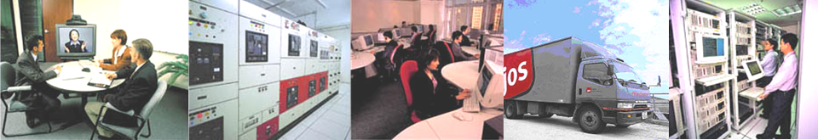

**Confidentiality**

|  |
| --- |
| The information contained herein is confidential and proprietary to **Jardine OneSolution (HK) Limited (JOS)** and **Maxim’s Caterers Limited (Maxim’s)**. It shall not be reproduced, or disclosed to others except by written permission from **JOS and Maxim’s.** The recipient of this document, by its retention and use, agrees to protect the information therein from unauthorized disclosure, loss, theft, and compromise. |

**Change Control**

|  |  |  |  |  |
| --- | --- | --- | --- | --- |
| **Document Title** | **Date** | **Prepared By** | **Version** | **Comment** |
| 1st Proposal | 22 August 2016 | Eric Lau | 1.0 |  |
| 2nd Proposal | 13 September 2016 | Eric Lau | 2.0 | Revise Scope of Work, update architecture and contract team sections. |
|  |  |  |  |  |
|  |  |  |  |  |
|  |  |  |  |  |
|  |  |  |  |  |

**JOS Contact**

For information on this proposal, please contact:

|  |  |
| --- | --- |
| Name:  Title:  Office:  Mobile:  Email: | Mr Eric Lau  Senior Sales Manager  2856 8075  9666 7554  eric.lau@jos.com.hk |
|  |  |

**Table of Content**

1 System Architecture 5

2 System Network Architecture 6

3 POS Polling Processing 7

3.1 Sales Data Polling 7

3.2 Pricing Data and other Master Data Processing 7

3.3 Master Data or Configuration Data Processing 8

4 Existing System Processing 9

5 Scope of Work 9

6 Key Assumptions 13

7 Project Management 14

7.1 Approach 14

7.2 Communication and Reporting 14

8 Project Duration 16

9 Project Price 16

10 Contract Terms 24

11 Acceptance Sign-off 18

Appendix A – Hardware Requirements 27

Appendix B – High-level Project Plan 29

Appendix C – Project Team Structure 29

Appendix D – Effort Estimation 32

# System Architecture

Below describe the logical components for the POS Polling using the Enterprise Service Bus (ESB).

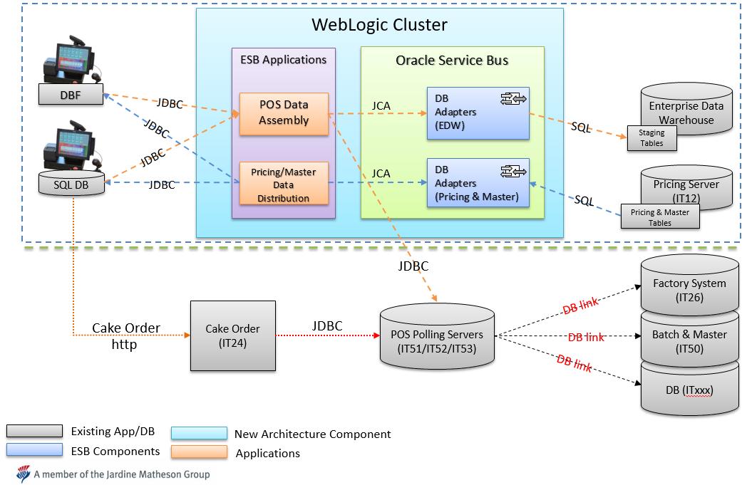

**Diagram -** System Architecture for the POS Polling using Enterprise Service Bus

Currently, POS system is sending/receiving data through database linked-servers. In the ESB implementation, Oracle Service Bus (OSB) with Customized ESB Layer will be introduced to replace the polling functionality of POS polling servers in IT51, IT52 and IT53 for synchronizing data between local database of the POS system in outlets and the back-office systems. Basically, the existing data synchronization (polling / pushing) logic in POS polling server will be ported to the Oracle ESB using java. As such, OSB server will schedule the data polling and data pushing periodically for data synchronization.

Depends on the configuration, Oracle ESB layer will use the JDBC to connect the database of the POS system in outlets by pre-configured connection information in order to collect sales data or updating pricing or master data. According to the existing polling logic found in IT51 server, when there is any connection error, Oracle ESB Layer will log the error and retry the data synchronization again. If the maximum retries reached, system will stop the synchronization for that particular POS system and generate alert for the synchronization failure. The POS connection information shall be retained as system configuration and can be flexibly maintained by Maxim IT.

For POS systems using DBF file as the exchange data media, the customized layer will directly read from / write to the DBF using the JDBC. The handling will be the same for both local database and DBF file.

The new ESB POS Polling can invoke several threads, which can be configured, to poll/push the data to the POS systems concurrently for maximizing performance.

# System Network Architecture

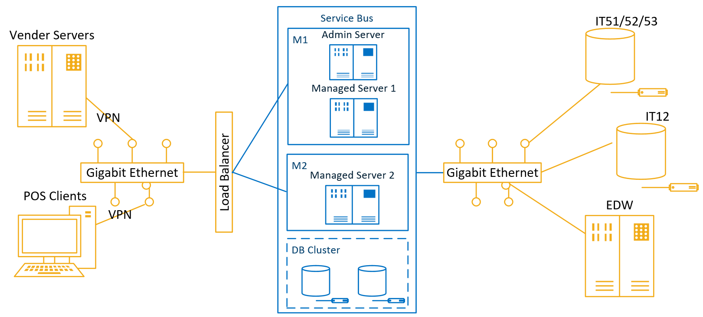

M1: Physical Machine 1 (or VM)

M2: Physical Machine 2 (or VM)

Managed Server 1 + 2 WebLogic Cluster

DB Cluster: Working DB (Oracle DB 11g or Above) for Service Bus Server installed in separate machines or VMs

Load Balancer: Apache HTTP Server/DNS

Blue: In scope

# POS Polling Processing

This section describes in more detail about how to synchronize sales data or pricing data between the POS systems and back-office systems.

## Sales Data Polling

According to the pre-defined polling period, Oracle ESB customized layer will use JDBC to make connection to the local database of the underlying POS systems (POS system host list will be stored in Oracle ESB server). Refer to the configuration for uploading, system will read the corresponding sales transaction records marked for synchronized (record status should be “P”). Then, system will trigger the **POS Data Assembly Layer** to connect to the EDW database with JDBC and update the Sales data staging tables in EDW.

As the EDW is already using staging tables for sales analysis or EOD processing, it is expected that EDW system will continue to process the sales data in staging tables as is. Hence, no change is required for the EDW system.

If there is any error found, Oracle ESB system will log the error and retry the update again until the retry count has been reached. Synchronized error can be investigated through the OSB.

For the phase implementation, Oracle ESB system will send the sales data of the ESB enabled POS systems to both EDW and the existing POS Polling Server database (IT51, IT52 and IT53). Hence, it will not impact the existing process as all sales data can be found in POS polling servers.

## Pricing Data and other Master Data Processing

Similar to the sales data processing, OSB will use **DB Adaptor** to monitor record changes in Pricing tables in IT12 database. For example, if the record status for Pricing record has been marked as “P”, Oracle ESB DB Layer will retrieve the changes through JDBC connection. After that, system will trigger the **Pricing Data Distribution Layer** to push the pricing data to the underlying POS systems. Actually, Customized Data Pushing Layer will also use JDBC to connect the local database in the POS system and update the staging table directly. Once staging tables updated, Layer will invoke remote stored procedure in POS system to merge the pricing data to POS system.

The pushing logic in existing stored procedure in IT51 server will be ported to the Data Pushing Layer using Java. For synchronization processing, system is allowed to setup the start/end time for the synchronization. If pricing data had been updated outsides the start/end time, e.g. End of Day, system will store the changes in the Pushing Layer temporarily and push the data to the underlying POS systems after the start time.

When there is any error found, e.g. network connection error, Oracle ESB system will log the error and retry the update according to the maximum retry count. If number of retry exceeds the limit, system will stop the synchronization for further investigation whilst alert emails shall be sent to support team for notification.

## Master Data or Configuration Data Processing

Other than the Pricing data, Master data or Configuration Data, e.g. access right, WIFI code, will be downloaded to the underlying POS system using the same method as the Pricing Data Processing.

# Existing System Processing

To simplify the implementation and minimize the impact to the existing services or applications, existing POS polling servers will continue to provide the functionalities as is, e.g. sales data conversion and centralized storage for the cake orders. In addition, it will continue to poll/push data to the non-ESB enabled POS systems. In short, these functions in existing POS Polling servers will remain unchanged, except NO polling or pushing data from those ESB-enabled POS systems.

# Scope of Work

Below is a list of customized items for the ESB Polling system.

1. **POS Data Assembly Layer** – web application to read the changed sales data from POS systems through JDBC and to post the relevant data to EDW’s staging tables. Please refer to the **stored procedures** as below for the data polling logic. In addition, this application layer will treat the sales data (ORDER, ORDER_EXTRA and ORDER_PAY) as a group for sending data.

|  |  |  |  |
| --- | --- | --- | --- |
| **No.** | **Stored Procedure Name** | **Server** | **Database** |
| 1 | udsp_check_polling_schedule | IT51 | Hopos |
| 2 | udsp_chk_poll_missing_branch | IT51 | common |
| 3 | udsp_poll_branch_data | IT51 | Hopos |
| 4 | udsp_poll_dbf_branch_data | IT51 | Hopos |
| 5 | udsp_poll_dbf_sales_file2 | IT51 | Hopos |

1. **Pricing Data Distribution Layer** – web application to update the pricing, master or other configuration data from back office system to the local database of the POS system and merge data by triggering the remote stored procedure in POS system. Please refer to the stored procedures in point 1 for data pushing logic.
2. **Setup and Develop interfaces in Oracle Service Bus**
   1. The installation of WebLogic Server and Oracle Service Bus to DEV, SIT, UAT and Production environment
   2. Develop the interfaces to handle the data synchronization, e.g. Sales data, Pricing and other configuration Data. Please refer to the List of POS Polling tables (total 66 tables)

|  |  |  |  |
| --- | --- | --- | --- |
| ***Table*** | ***Type*** | ***Update Freq.*** | ***Up/Down*** |
| ACCOUNTS | Master | Every Polling | Download |
| COUPON_CONTROL | Master | Every Polling | Download |
| COUPON_RANGE | Master | Every Polling | Download |
| CURRENCY | Master | Every Polling | Download |
| EMPLOYEE | Master | Every Polling | Download |
| HIST_CHECK_LOGS | HIST | EOD | Upload |
| HIST_COUPON_SALES | HIST | EOD | Upload |
| HIST_ITEM | HIST | EOD | Upload |
| HIST_ITEMSTOCK | HIST | EOD | Upload |
| HIST_ORDERS | HIST | EOD | Upload |
| HIST_ORDERS_EXTRA | HIST | EOD | Upload |
| HIST_ORDERS_PAY | HIST | EOD | Upload |
| HIST_ORDERS_PAY_PROGRESS | HIST | EOD | Upload |
| HIST_PAYFIG | HIST | EOD | Upload |
| HIST_PAYSUM | HIST | EOD | Upload |
| HIST_POSSYSTEM | HIST | EOD | Upload |
| HIST_REDEEMED_COUPON | HIST | EOD | Upload |
| HIST_SAFEBOXCHECK | HIST | EOD | Upload |
| HIST_SAFEBOXCHECKTENDER | HIST | EOD | Upload |
| HIST_SAFEBOXINOUT | HIST | EOD | Upload |
| HIST_SAFEBOXINOUTEXTENDINFO | HIST | EOD | Upload |
| HIST_SAFEBOXPICKUP | HIST | EOD | Upload |
| HIST_SESSIONINFO | HIST | EOD | Upload |
| HIST_SESSIONTENDER | HIST | EOD | Upload |
| HIST_STOCK_MOVEMENT | HIST | EOD | Upload |
| HIST_SUPP | HIST | EOD | Upload |
| HIST_TRANS | HIST | EOD | Upload |
| HIST_TRANS_ECARD | HIST | EOD | Upload |
| HIST_TRANS_MODIFIER | HIST | EOD | Upload |
| INVITATION | Master | Every Polling | Download |
| ITEM | Master | Every Polling | Download |
| ITEM_BARCODE | Master | Every Polling | Download |
| ITEM_MODIFIER | Master | Every Polling | Download |
| ITEMANLY | Master | Every Polling | Download |
| ITEMDEPT | Master | Every Polling | Download |
| MENU | Master | Every Polling | Download |
| MENUITEM | Master | Every Polling | Download |
| MESSAGES | Master | Every Polling | Download |
| MODIFIER | Master | Every Polling | Download |
| MODIFIER_GRP | Master | Every Polling | Download |
| MODIFIER_LIST | Master | Every Polling | Download |
| ONHOUSE | Master | Every Polling | Download |
| OPTIONS | Master | Every Polling | Download |
| ORDERS | Sales Data | Every Polling | Upload |
| ORDERS_EXTRA | Sales Data | Every Polling | Upload |
| ORDERS_PAY | Sales Data | Every Polling | Upload |
| PAYCAT | Master | Every Polling | Download |
| PAYMENT | Master | Every Polling | Download |
| PMT_ACTION | Master | Every Polling | Download |
| PMT_CONDITION | Master | Every Polling | Download |
| PMT_HDR | Master | Every Polling | Download |
| POSBUSDATE | Master | Every Polling | Download |
| ROLE | Master | Every Polling | Download |
| ROLE_PERMISSION | Master | Every Polling | Download |
| SUPP | Sales Data | Every Polling | Upload |
| SYSSETTINGS | Master | Every Polling | Download |
| TRANS | Sales Data | Every Polling | Upload |
| TRANS_ECARD | Sales Data | Every Polling | Upload |
| TRANS_MODIFIER | Sales Data | Every Polling | Upload |
| TRANS_TYPE | Master | Every Polling | Download |
| USER_PERMISSION | Master | Every Polling | Download |
| USER_ROLE | Master | Every Polling | Download |
| WIFI CODE | Master | Every Polling | Download |
| HIST_TRANSSUMMARY | HIST | EOD | Upload |
| HIST_VOIDORDERS | HIST | EOD | Upload |
| HIST_VOIDTRANS | HIST | EOD | Upload |

1. **Sales Data DB Adapter/Customized Layer** – web application to update the sales data to the staging tables stored in EDW system and to replicate the sales data to existing IT51, IT52 and IT53 servers. The OSB service will consider the relationship of the order item, order extra and order payment, aims to implement the wrapped data service which could receive service request of the data of these 3 tables. Please refer to the **List of POS Polling tables** in point (3) with Type = Sales Data and HIST (total 34 tables).
2. **Pricing Data DB Adapter/Customized Layer** for Pricing or Master/Configuration Data – develop the DB Layer to monitor the data changed in Pricing, Master and Configuration Data. Please refer to the **List of POS Polling tables** in point (3) with type = **Master** (total 32 tables)
3. **Reports (total 2 reports)**
   1. **Oracle ESB Exception Report** - to show the exceptions, connectivity errors in the Oracle ESB system.
   2. **Polling Summary Report** – to show summary of the healthiness of polling including connectivity, job status, exceptions per hour.
4. **First Time Deployment Support** – provide the support for the first time deployment for the Oracle ESB implementation.
5. **Deliverable Documents** – the following documents will be delivered for the project implementation: -
   1. Project Charter
   2. Project Plan with Task Breakdown
   3. Impact Analysis Report
   4. Weekly Project Status Summary
   5. Business Requirement Definition
   6. System Design Specification
   7. Technical Specification
   8. Installation Guide
   9. Unit Test Report
   10. System & Integration Test Plan
   11. System & Integration Test Defect Log
   12. System Performance Report
   13. Training Document
   14. Operational Manual
   15. Implementation Plan
   16. Project Closure for IT

# Key Assumptions

Below are key assumptions to the Oracle ESB implementation services quoted in this proposal.

1. Any change not mentioned in Scope of Work is assumed to be handled by Maxim’s IT, e.g. sales analysis and reporting for sales data should be handled by EDW system.
2. EDW system should provide staging tables for **POS Data Assembly Layer** to store the sales data from those ESB enabled POS systems. Besides, EDW should adjust the data interfaces to suppress the sales data from the exiting POS Polling servers (IT51, IT52 and IT53).
3. EDW system should handle the data from ESB enabled POS system whereas existing POS polling system should continue to handle all sales data from all POS systems. EDW system should modify the ODI existing interface to skip the duplicate sales data from those ESB enabled POS systems.
4. The program logic ported to Customized Data Polling/Pushing Layer should follow the polling/pushing logic found in database **hopos** and **common** in IT51 server only. Program logic found in other database will be out of scope, e.g. hopos_chi or hopos_backup, etc.
5. **Oracle ESB Exception Report** shows only the exception for those ESB enabled POS system. For those non-ESB enabled POs system, error message should refer to the existing POS Polling process.
6. For hardware and system performing estimation, it is assuming that the maximum transaction growth rate should be less than 10%, based on the current transaction volume for all POS systems, the maximum transaction volume to be handled by Oracle ESB as below:

| **No.** | **Items** | **Current transactions/day** | **Projected Transactions/day in next 5 years** |
| --- | --- | --- | --- |
| 1 | Orders counts | 580,000 | = 580,000 * (1+10%)5  = 934,095.8 |
| 2 | Order items | 1,450,000 | = 1,450,000* (1+10%)5  = 2,335,239.5 |
| 3 | Order Payments | 650,000 | = 650,000* (1+10%)5  = 1,046,831.5 |

**IMPORTANT**:

1. End-to-end performance would be limited by Application layer and DB layers
2. Server nodes are scalable while utilizing WebLogic Cluster

# Project Management

## Approach

The successful completion of any project depends on the careful execution of a well-structured and detailed plan. The project plan will be prepared by project manager including schedules, processes, and dependencies. This plan will be used to control the project, monitor all activities, track progress, and manage change control.

Serving as a focal point of contact, there will be a project manager to be responsible for the overall success of the project. The Project Manager will manage communications with Maxim and work closely with the relevant key stakeholders for daily operations of this project. The Project manager will provide updates to Maxim’ regularly on the activities related to this project.

Recognizing that the scope of the project may require changes, the project management should introduce a formal change control procedure. This proven approach will allow the PSC to make cost and benefit trade-offs based on an analysis of requested changes.

The project management services shall include following: -

* to conduct a project kick off meeting with Maxim at the inception of the services;
* serving as a focal point of contact and responsible to manage communications with Maxim;
* to report progress regularly by providing regular status update to Maxim assigned representative;
* to prepare project plan;
* to monitor and control the project to ensure the project is being executed in accordance to the agreed project schedule;
* to manage the issues related to the project, maintain the Issue Log as well as to ensure issues raised are adequately and promptly addressed;
* to carry out the change management such as the conduct regular communication meetings and presentation, change in business operations or that are associated with the project, and prepare Change Request Form & Log if necessary

## Communication and Reporting

Communication is important throughout the project life cycle. Throughout the project, the major communications will be prepared and broadcast by means of message:

* To support the project activities
* To deliver detailed instructions and information
* To provide different effective channels to collect user comments
* To deliver prompt feedbacks

***User Communication***

Communication session will be organized for business users to share the project timeline and seek for business support to identify key stakeholders for respective business units and department to participate in key project activities such as business requirement collection and consolidation, user acceptance test, and rollout planning.

***Project Team Communication***

The communication sessions will be organized to the project team to make sure the project is delivered according to the project schedule. There will be three different types of meetings during the implementation services: -

* **Project Steering Committee (PSC) Meeting**

The Project Steering Committee and Project Lead will facilitate the Project Management meetings when necessary to track progress against the Project Plan and resolve deviations. The frequency of PSC meeting will be confirmed during kick-off meeting.

* **Project Progress Meeting**

The Project Manager will hold meetings with Project Team on a regular basis (e.g. bi-weekly or monthly) and when needed. The purpose of the meeting is to review the project progress, to record the product status and to solve any problems, project issues and exception situation and make recommendation to the PSC. Frequency of meetings may be adjusted if considered necessary.

***Status Report***

A status report will be prepared by Project Manager and provide to all project team members.

# Project Duration

4 months

# 

# Project Price

To be confirmed

# Contract Terms

* Price quoted herein is valid till 30 September 2016, subject to change without further notice. The customer should sign back the agreement with company chop within the period, otherwise subject to JOS’s acceptance.
* Payment term:
* 40% initial payment once order confirmation
* 30% payment after signed SIT
* 20% payment after signed UAT
* 10% balance payment 1 month after signed UAT
* For any quote in US dollars, the price quoted is only valid if the official HSBC spot exchange rate for US$:HK$ is within +5.0% or -5.0% of 7.80.
* All payments shall be made payable to Jardine OneSolution (HK) Ltd.
* Amount unpaid after the invoice due date will bear interest from the due date until the date payment is made in full at a rate of two per cent (2%) per month (or pro-rata for each day).
* Refer to Application Master Service Agreement

# Acceptance Sign-off

The parties below hereby accept this proposal.

Accepted By:

Maxim’s Caterers Ltd.

|  |  |
| --- | --- |
| Signature: |  |
| Name: |  |
| Title: |  |
| Date: |  |

Accepted By:

Jardine OneSolution (HK) Ltd.

|  |  |
| --- | --- |
| Signature: |  |
| Name: |  |
| Title: |  |
| Date: |  |

# 

# Appendix A – Hardware Requirements

|  |  |  |  |  |  |  |
| --- | --- | --- | --- | --- | --- | --- |
| **#** | **Environment** | **Description** | **Type** | **Hardware** | **Software** | **Remark** |
| 1 | DEV | Oracle ESB Server | Physical Machine | O/S: REHL 6.4 CPU: 4 cores Xeon @ 2.1Mhz Memory: 16G Hard disk: 2TB SAN Disk | WebLogic server, Oracle ESB Server 11g | No clustering support for testing environment. |
| 2 | UAT | Oracle ESB Server 1 (Clustering) | Physical Machine | O/S: REHL 6.4 CPU: 8 cores Xeon @ 2.1Mhz Memory: 48G Hard disk: 2TB SAN Disk | WebLogic server, Oracle ESB Server 11g | Hardware Load Balancer is required for Clustering. |
| 3 | UAT | Oracle ESB Server 2 (Clustering) | Physical Machine | O/S: REHL 6.4 CPU: 8 cores Xeon @ 2.1Mhz Memory: 48G Hard disk: 2TB SAN Disk | WebLogic server, Oracle ESB Server 11g | Hardware Load Balancer is required for Clustering. |
| 4 | Production | Oracle ESB Server 1 (Clustering) | Physical Machine | O/S: REHL 6.4CPU: 8 cores Xeon @ 2.1Mhz Memory: 48G Hard disk: 6TB SAN Disk | WebLogic server, Oracle ESB Server 11g | Hardware Load Balancer is required for Clustering. |
| 5 | Production | Oracle ESB Server 2 (Clustering) | Physical Machine | O/S: REHL 6.4 CPU: 8 cores Xeon @ 2.1Mhz Memory: 48G Hard disk: 6TB SAN Disk | WebLogic server, Oracle ESB Server 11g | Hardware Load Balancer is required for Clustering. |

# Appendix B – High-level Project Plan

|  |  |  |  |  |  |  |  |  |  |  |  |  |  |  |  |  |  |  |  |  |  |
| --- | --- | --- | --- | --- | --- | --- | --- | --- | --- | --- | --- | --- | --- | --- | --- | --- | --- | --- | --- | --- | --- |
| **No.** | **High Level Project Timeline** |  | Week1 | Week2 | Week3 | Week4 | Week5 | Week6 | Week7 | Week8 | Week9 | Week10 | Week11 | Week12 | Week13 | Week14 | Week15 | Week16 | Week17 | Week18 | Week19 |
| 1 | **Project Initialization** |  |  |  |  |  |  |  |  |  |  |  |  |  |  |  |  |  |  |  |  |
| 2 | **User Requirement Confirmation** |  |  |  |  |  |  |  |  |  |  |  |  |  |  |  |  |  |  |  |  |
| 3 | **Hardware/VPN/Environment Setup** |  |  |  |  |  |  |  |  |  |  |  |  |  |  |  |  |  |  |  |  |
| 4 | **System Analysis and Design** |  |  |  |  |  |  |  |  |  |  |  |  |  |  |  |  |  |  |  |  |
| 5 | **System Development** |  |  |  |  |  |  |  |  |  |  |  |  |  |  |  |  |  |  |  |  |
| 6 | **System Test** |  |  |  |  |  |  |  |  |  |  |  |  |  |  |  |  |  |  |  |  |
| 7 | **System Integration Test** |  |  |  |  |  |  |  |  |  |  |  |  |  |  |  |  |  |  |  |  |
| 8 | **User Acceptance Test** |  |  |  |  |  |  |  |  |  |  |  |  |  |  |  |  |  |  |  |  |
| 9 | **Operation Acceptance Test** |  |  |  |  |  |  |  |  |  |  |  |  |  |  |  |  |  |  |  |  |
| 10 | **Capacity, Performance and Penetration Test** |  |  |  |  |  |  |  |  |  |  |  |  |  |  |  |  |  |  |  |  |
| 11 | **Training** |  |  |  |  |  |  |  |  |  |  |  |  |  |  |  |  |  |  |  |  |
| 12 | **Deployment** |  |  |  |  |  |  |  |  |  |  |  |  |  |  |  |  |  |  |  |  |
| 13 | **Post Implementation** |  |  |  |  |  |  |  |  |  |  |  |  |  |  |  |  |  |  |  |  |

**Note:** Nursing Period is 3 months

# Appendix C – Project Team Structure

**Project Manager**



**Solution Architect**



**System Analysts**

********

**Analyst Programmers**

 

# Appendix D – Effort Estimation

|  |  |  |  |  |  |  |  |  |  |
| --- | --- | --- | --- | --- | --- | --- | --- | --- | --- |
| **Task** | **Project Manager** | **Solution Architect** | **System Analyst 1** | **System Analyst 2** | **Analyst Programmer 1** | **Analyst  Programmer 2** | **Tester 1** | **Tester 2** | **Remarks** |
| **Project Management** |  |  |  |  |  |  |  |  |  |
| Meeting and communication | 14 |  |  |  |  |  |  |  | For coordinate with Maxim IT, coordinate with business teams for UAT and design approval, study clarification, coordinate with IT security for security test, coordinate with capacity team for load test, coordinate with Maxim Infrastructure team to setup environments.. Communication overhead: infrastructure and network vendor: HW set, UAT and OAT (4 weeks x 0.5 MD) Maxim IT team: SA&D (4 weeks x 0.5); UAT(4 weeks x 0.5); implementation (12 weeks x 0.5 MD); IT security / UAT Users: 2 MD |
| Prepare PMP | 5 |  |  |  |  |  |  |  | Prepare for the project kick off meeting. |
| Progress Monitoring and Control | 18 |  |  |  |  |  |  |  | One day per week to oversee the project progress, risk and issues. (including report progress) |
| Post Implementation Review / Report; Maintenance Transition | 4 |  |  |  |  |  |  |  | For document learn project wrap-up, and maintenance transition (8 x 0.5 day) |
| Other PM related documentation | 5 |  |  |  |  |  |  |  |  |
| **Environment Setup** |  |  |  |  |  |  |  |  |  |
| Impact Analysis (on POS System and EDW) |  | 3 | 3 |  |  |  |  |  | IT51/52/53 and related linked servers in-depth study |
| Collect Business Requirement & Generate Requirement Definition document |  |  |  | 5 |  |  |  |  |  |
| Prepare Development Environment |  |  |  | 1 | 1 |  |  |  | 1 x WebLogic; 1 x OSB, 1 x Enterprise Pack (2 x MD) |
| Prepare Test Environment (SIT, UAT and PROD) - Installation and configuration, hardening, documentation - WebLogic - Oracle Service Bus |  | 2 |  | 1 | 2 | 2 |  |  | SIT: 1 x WebLogic Cluster 1 x OSB, 1 x Enterprise Pack (3 x MD) UAT: 1 x WebLogic; 1 x OSB, 1 x Enterprise Pack (2 x MD, leverage the DEV configure) UAT: 1 x WebLogic; 1 x OSB, 1 x Enterprise Pack (3 x MD, leverage the SIT configure)   UAT Environment Checklist UAT Environment Setup Steps |
| **System Analysis and Design** |  |  |  |  |  |  |  |  |  |
| Review and Confirm Specification |  | 2 | 4 | 4 |  |  |  |  | Define requirements (functional and non-functional) catalogue and develop traceability matrix. |
| Design Walkthrough Workshop (2 workshops) |  | 3 | 3 | 3 |  |  |  |  | Including workshop material preparation, 1st workshop to review all data flows, program flows, I/O, etc., 2nd workshop for finalize the design for below items 1 day for revision - Service Bus Design - Polling Applications (End-to-end) - Pricing & Master Interface Design |
| Produce Impact Analysis Report |  | 3 |  | 3 |  |  |  |  |  |
| Produce Functional Design Specification |  | 3 | 5 | 4 |  |  |  |  | 5 MD for EDW DB Adapters and POS Polling Application 4 MD for Pricing Data and Master Data DB Adapters and Distribution agents 3 MD Architect for OSB design |
| Produce Testing Strategy and Plan |  |  | 3 |  |  |  |  |  |  |
| **System Development** |  |  |  |  |  |  |  |  |  |
| Produce Technical Design Specification (OSB) |  | 2 |  | 2 | 2 |  |  |  | Document DFD, data dictionary, component specification, etc. |
| Produce Technical Design Specification (POS Polling Application) |  |  | 2 |  | 3 |  |  |  |  |
| Produce Technical Design Specification (EDW DB Adapters) |  |  | 1.5 |  | 2 |  |  |  | EDW - 8 Services 0.5 days for each |
| Produce Technical Design Specification (Pricing Data interfaces) |  |  |  | 1.5 |  | 2 |  |  |  |
| Produce Technical Design Specification (Master data Interfaces) |  |  |  | 1.5 |  | 2 |  |  |  |
| Produce Unit Test Plan |  |  |  |  | 3 | 3 |  |  |  |
| Code Review and Supervising (Internal) |  |  | 6.6 | 9.75 |  |  |  |  | Approximate 20% of overall coding effort |
| Development and Unit Testing (Data Polling Process - Java Application) 2 Tiers 1. POS Clients 2. Sales Servers (IT12/13/18/19) |  |  | 10 |  | 33 |  |  |  | Sales Data Number of interfaces: 800+ Types of interfaces 1. DBF 2. MS SQL Server 3. MySQL Number of Tables Real time process: 39 EOD process: 24 Non-functional requirements: - Job control and monitoring - Re-run mechanism - Contingency |
| Development and Unit Testing (EDW DB Adapters) |  |  |  | 7 |  | 22 |  |  | Sales Server DB Adapters: similar |
| Service Bus Implementation and Testing (Pricing Data/Master Data DB Adapter) |  |  |  | 6 |  | 17 |  |  | *DB Adapter monitor table changes and distribute to POS clients *other data process unknown |
| Service Bus Reporting |  |  |  | 2 |  | 5 |  |  | - Exception Report - Daily Summary Report |
| Check Point (review with integration approval) |  | 1 | 1 | 1 | 1 | 1 |  |  | Prepare the prototype for IT and business users to participate, and approve. Tasks including build demo DB, story board and PowerPoint material.  3 Tier, 1 checkpoint for each tier and all member shall be involved |
| Deploy to SIT environment |  |  |  |  | 2 | 2 |  |  |  |
| Draft Integration Test Plan |  |  |  |  |  |  | 3 | 3 |  |
| **System Integration Test** |  |  |  |  |  |  |  |  |  |
| Produce Integration Test Plan |  |  | 2 | 2 |  |  | 3 | 3 | POS data processing, 5 types of data processing with 6-8 cases each  - master data  - pricing data  - sales data  - day end processing request - Other (Schedule retry, ad hoc trigger, connectivity, etc.) |
| Conduct Integration Test (EDW End-to-End - Sales Data Service) |  |  | 2 |  | 5 |  | 15 |  | Testing Efforts Bug Fix Efforts QA efforts |
| Conduct Integration Test (Pricing & Master Data End-to-End Test) |  |  |  | 2 |  | 5 |  | 12 | Testing Efforts Bug Fix Efforts QA efforts |
| Conduct Integration Test (Operational function and reporting testing) |  |  |  | 1 |  | 2 |  | 3 | Testing Efforts Bug Fix Efforts QA efforts |
| Deploy to UAT environment |  |  | 2 | 2 | 3 | 3 |  |  |  |
| **IT Acceptance Test** |  |  |  |  |  |  |  |  |  |
| Conduct usability test |  |  | 1.5 | 1.5 | 3 | 3 |  |  | Conduct with Maxim's IT (3 session only). |
| **User Acceptance Test** |  |  |  |  |  |  |  |  |  |
| Prepare UAT Plan (by Maxim) |  |  |  |  |  |  |  |  | Assuming Maxim's IT managed to coordinate the business users and plan for UAT, JOS mainly assists in providing technology supports and/or certain documentation. |
| Training Material (Operations, Administration and Reporting) |  |  |  | 2 |  |  |  |  | Assuming leveraging User Manual's content to produce the training material |
| Conduct UAT Briefing and Training |  |  |  | 2 |  |  |  |  | Includes prepare UAT briefing material, demo site for train the UAT testers (1 session only). |
| Conduct Training Sessions (Technical, Operation and Business) |  |  |  | 3 |  |  |  |  | Provides training to internal technical staffs, operation staffs and business on the new system, in terms of the operation, administration and reporting. Assumed train to trainer approach, 2 skill transfer sessions for technical and operation staffs, in presentation format (one-way), could illustrate the operations and administration steps side-by-side. 1.5 day for each session, thus total 1.5 x 2 = 3 MD |
| Conduct and Support UAT |  |  | 20 |  | 20 |  |  |  | Conduct testing, minor changes fix, log review and reporting (assumed 4-weeks duration, 1 log review session per week).  Daily UAT log will be reviewed (conf. call) for consolidation. Each Week SA x 1 day, AP x 1 days |
| Prepare Operational Manual |  |  |  | 2 |  |  |  |  |  |
| Prepare Administration Guides (Installation and Configuration) |  |  |  | 2 |  |  |  |  |  |
| **Performance and Penetration Test** |  |  |  |  |  |  |  |  |  |
| Prepare performance test cases and scripts |  |  |  | 1 |  | 2 |  | 3 |  |
| Perform performance test |  |  |  | 2 |  | 4 |  | 10 | 2 Days SA + 4 Days AP to performance tuning |
| **Operation Acceptance Test** |  |  |  |  |  |  |  |  |  |
| Conduct OAT (including Resilience (HA) and Disaster recovery (DR) Test | 1 | 1 | 1 | 1 |  |  |  |  |  |
| **Implementation** |  |  |  |  |  |  |  |  |  |
| Prepare Implementation Plan |  | 1 | 1 | 1 |  |  |  |  | Prepare, review at least twice, and final work through. |
| Production Setup Implementation |  | 1 | 2 | 2 |  |  |  |  |  |
| **Documentation** |  |  |  |  |  |  |  |  |  |
| System Manual |  |  | 2 |  |  |  |  |  |  |
| **Post Implementation** |  |  |  |  |  |  |  |  |  |
| Maintenance Transition | 1 | 2 | 3 | 3 |  |  |  |  |  |
|  | 1 |  |  |  |  |  |  |  |  |
|  | 49 | 24 | 75.6 | 81.25 | 80 | 75 | 21 | 34 |  |
|  |  |  |  |  |  |  |  | 439.85 |  |